**Project Design Phase-II**

**Data Flow Diagram & User Stories**

**Real-Time River Water Quality Monitoring and Control System**

**Data Flow Diagrams:**

A Data Flow Diagram (DFD) is a traditional visual representation of the information flows within a system. A neat and clear DFD can depict the right amount of the system requirement graphically. It shows how data enters and leaves the system, what changes the information, and where data is stored.

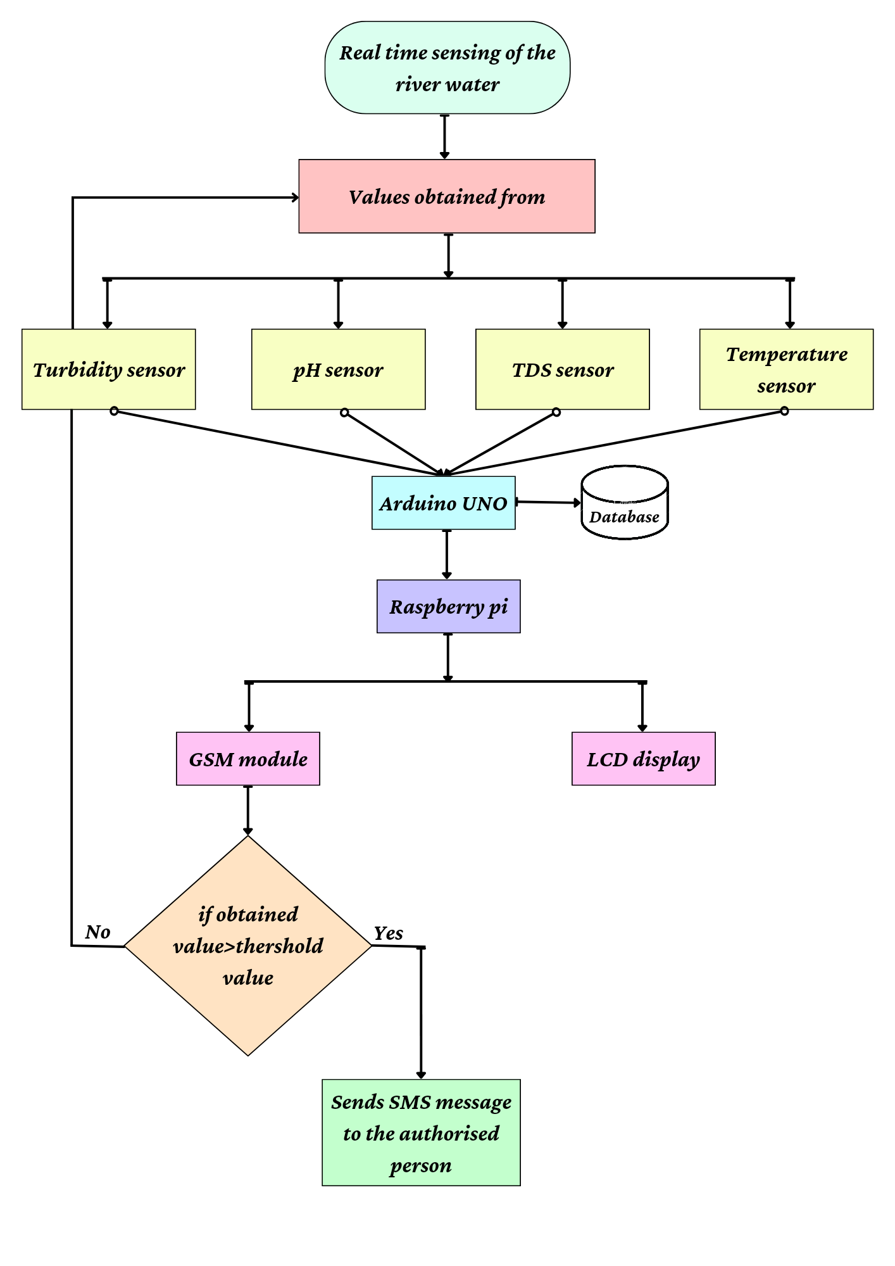

| **User Type** | **Functional Requirement (Epic)** | **User Story Number** | **User Story / Task** | **Acceptance criteria** | **Priority** | **Release** |
| --- | --- | --- | --- | --- | --- | --- |
| Customer (Mobile user) | Registration | USN-1 | As a user, I can register for the application by entering my email, password, and confirming my password. | I can access my account / dashboard | High | Sprint-1 |
|  |  | USN-2 | As a user, I will receive confirmation email once I have registered for the application | I can receive confirmation email & click confirm | High | Sprint-1 |
|  |  | USN-3 | As a user, I can register for the application through Google | I can register & access the dashboard with Google Login | Low | Sprint-2 |
|  |  | USN-4 | As a user, I can register for the application through Gmail | I can register & access the dashboard with Gmail Login | Medium | Sprint-1 |
|  | Login | USN-5 | As a user, I can log into the application by entering email & password | I can receive login credentials | High | Sprint-1 |
| Customer (Web user) | Dashboard | WU-1 | As a web user, I can access the information of pH levels, turbidity, temperature and TDS | I can know how quality the water is | High | Sprint-1 |
| Customer Care Executive | All specifications | CCE-1 | As a customer care executive, I can able to know the quality of water in every aspect | I can easily know whether the water is safe or not | High | Sprint-1 |
| Administrator | Maintenance | ADMIN | As a administrator should organize the whole process in a perfect manner | I can easily maintain the system | High | Sprint-1 |